New features of SQL Server 2016

Objectives
At the end of this session, the student will be able to:
- Understand the new features of SQL Server 2016

- Using FOR JSON clause :
Using Northwind database

select ProductID, ProductName, UnitPrice from Products
for json auto

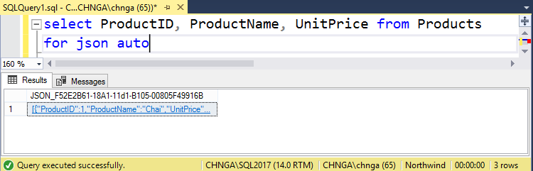

Display result in https://jsoneditoronline.org/

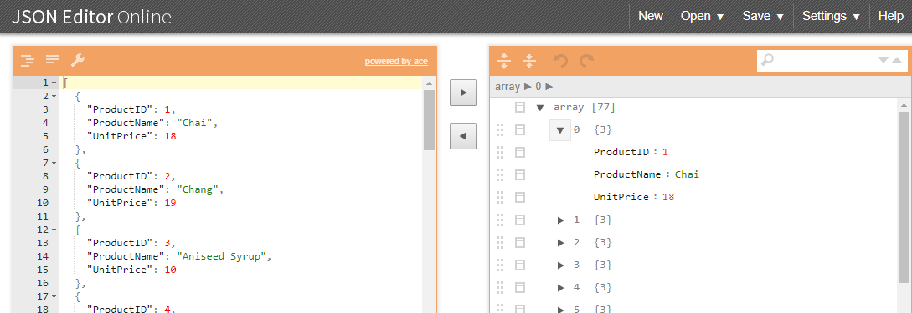

Select EmployeeID, FirstName as "EmployeeName.FirstName", LastName as "EmployeeName.LastName", HireDate
from Employees
For JSON path , root('Employee')

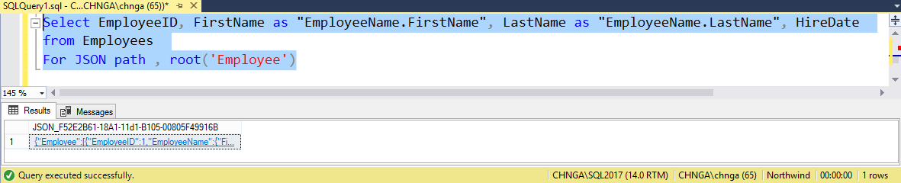

Display result in https://jsoneditoronline.org/
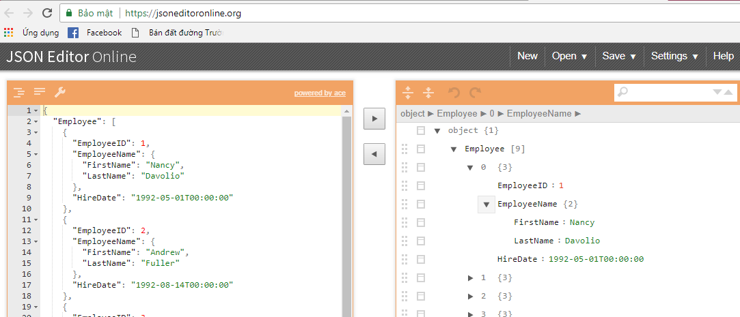

- Compare execution plan :
Create the table Employee, with 500,000 records.
CREATE TABLE dbo.Employee(
Id INT IDENTITY(1,1) NOT NULL PRIMARY KEY,
EmpName NVARCHAR(50), MobileNumber NVARCHAR(20),
StartDate DATETIME, ChangeDate DATETIME)
GO

INSERT INTO dbo.Employee(EmpName, MobileNumber,
StartDate, ChangeDate)
SELECT TOP 500000 NEWID(),
100000000 - ROW_NUMBER() OVER (ORDER BY SC1.object_id),
GETDATE(), GETDATE()
FROM SYS.all_columns SC1
CROSS JOIN SYS.all_columns SC2

In the SSMS window, enable the actual executon plan (Query → Include Actual Executon Plan or CTRL + M). Then, execute a query to retrieve a phone number.

SELECT *
FROM dbo.Employee WITH(NOLOCK)
WHERE MobileNumber = '99990000'

The resul of the executon plan
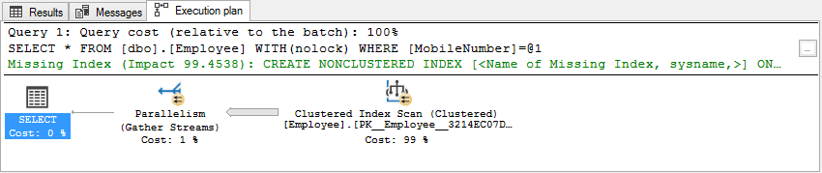

Save the executon plan as FirstExecutonPlan.sqlplan
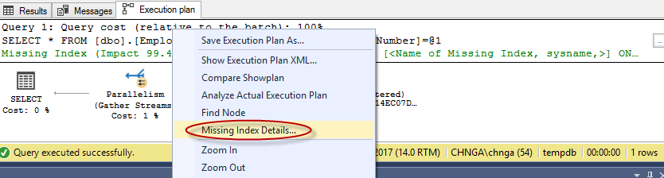

Create suggestion index:
CREATE NONCLUSTERED INDEX IX_Employee_MobileNumber
ON [dbo].[Employee] ([MobileNumber])

Re-execute the query on MobileNumber. Save the executon plan as SecondExecutonPlan.sqlplan
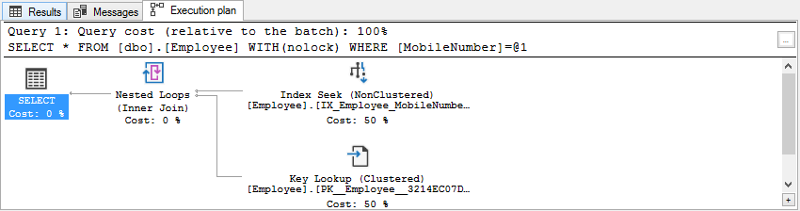

In SSMS, open the saved FirstExecutonPlan.sqlplan and right-click the tab. The Compare Showplan
opton is available as shown in following figure
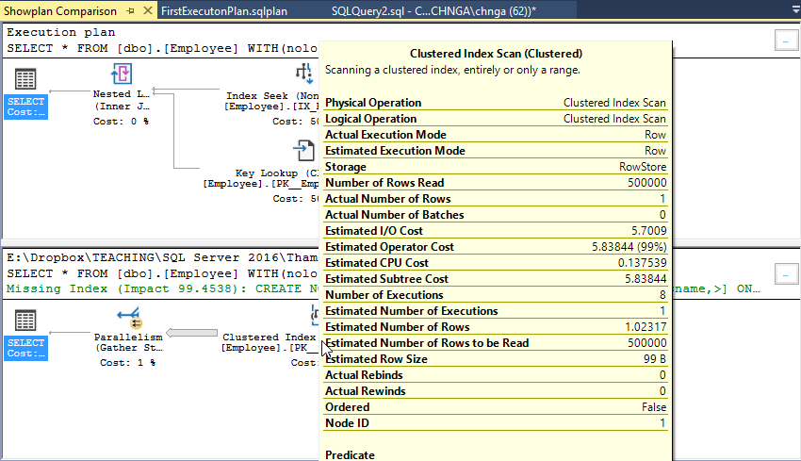

- Setting Versioning of Tables
Create table BankAccount with System Version Table BankAccountPast
CREATE TABLE BankAccount
(AccountNumber int PRIMARY KEY,
Balance float,
ValidFrom datetime2 generated always as row start not null,
ValidTo datetime2 generated always as row end hidden not null,
Period for system_time(ValidFrom, ValidTo))
WITH (SYSTEM_VERSIONING=on (HISTORY_TABLE=dbo.BankAccountPast))

Insert a record in the table.
INSERT INTO BankAccount(AccountNumber, Balance) VALUES(666999, 10100)

Now, update the bank account balance
UPDATE BankAccount SET Balance=Balance-2500
WAITFOR DELAY '00:00:10'
UPDATE BankAccount SET Balance=Balance+1000

Query data on the two table
SELECT * FROM BankAccount
SELECT * FROM BankAccountPast

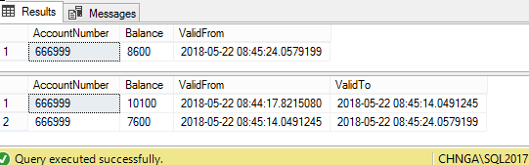

Disabling system-versioning
ALTER TABLE BankAccount SET (SYSTEM_VERSIONING =OFF)
Enable system-versioning
ALTER TABLE dbo.[Department]
SET (SYSTEM_VERSIONING = ON (HISTORY_TABLE =dbo.[DepartmentHistory]))

